**Assignment 32.3**

**Problem Statement:**

● Write a Java client API to perform following operations:

● Use HBaseAdmin class and create the table named company with one column family name details.

● Create the method name insert and use put class to insert records to company table.

**Program:**

* **Create method:**

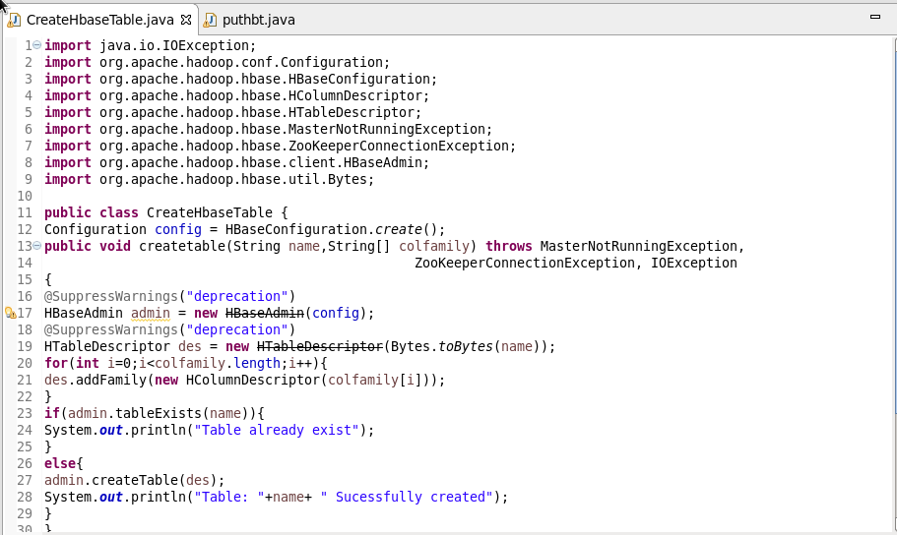

**Output:**

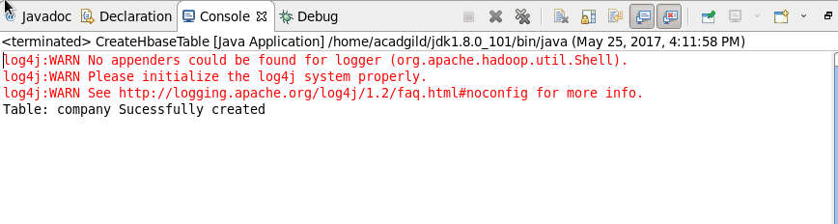

We can check in HBase using **‘list’** command as below:

The table **‘company’** is created.

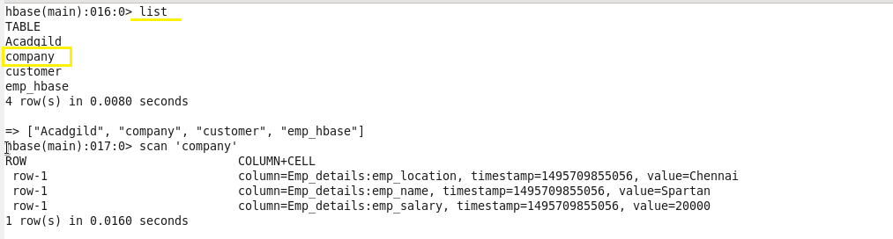

* **Insert method:**

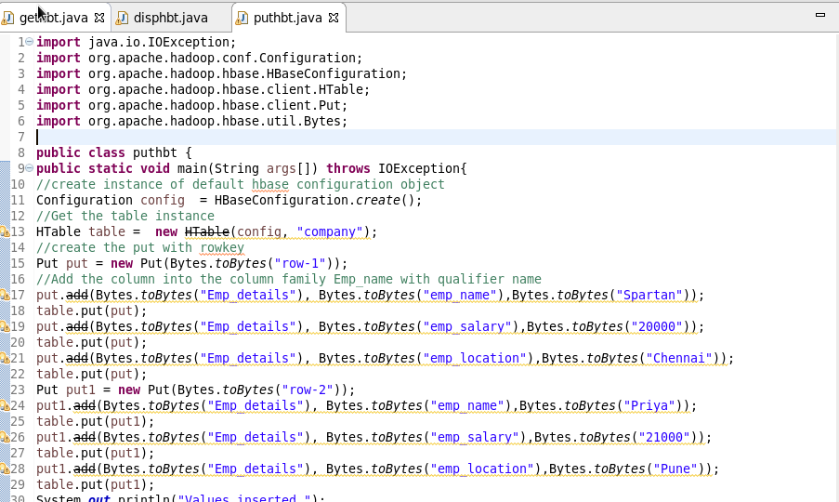



**Output:**

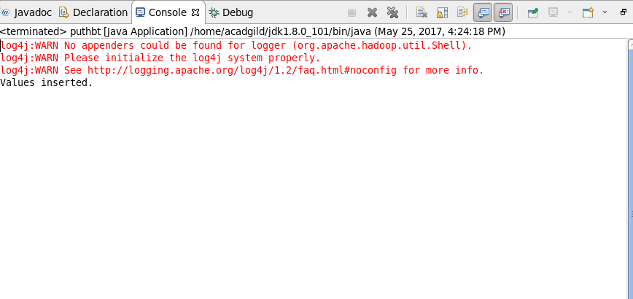

We can check in HBase using **‘scan’** command as below:

The records are inserted in table **‘company’** successfully.

